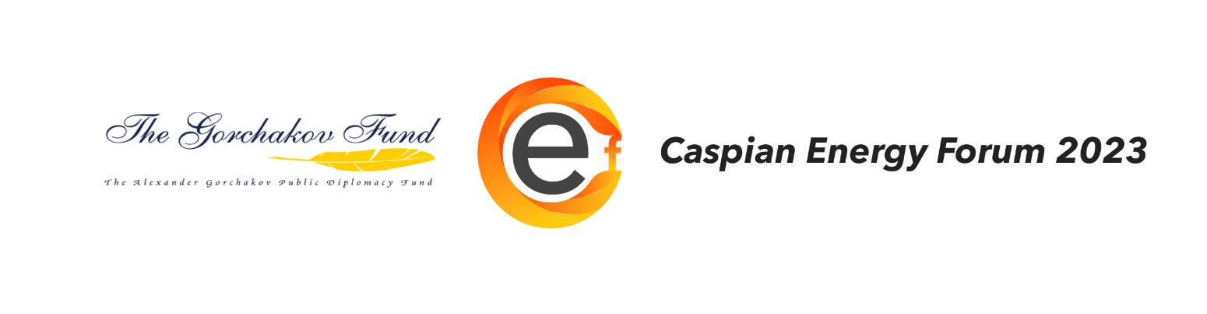

**The 15th Caspian Energy Forum**

**"Energy Dialogue in the Context of ensuring international Energy Security"**

**on April 20, 2023.**

**Moscow**

The most important goal of the Caspian Energy Dialogue is to promote international, interregional and national energy security. As practice shows, the development of energy dialogue with all subjects of the energy markets of the Caspian region, the expansion of directions and the introduction of new forms of scientific and technological cooperation contributes to the modernization and innovative renewal of branches of the fuel and energy complex, which is the locomotive of the economy of the countries of the region, and positively affects the organization of uninterrupted supplies of hydrocarbon resources to foreign markets. In addition, the introduction of environmentally friendly and resource-saving technologies and equipment at oil and gas producing enterprises, oil and gas processing complexes and pipeline transport contributes to ensuring the environmental safety of the Caspian Sea.

**The mission of the annual Caspian Energy Forum is to achieve these goals.**

**On April 20, 2023, the 15th Caspian Energy Forum** (hereinafter referred to as the Forum) is planned to be held in Moscow in the MGRI conference Hall (23 Miklukho-Maklaya Str., Moscow, 117997) with the support of the A.M. Gorchakov Public Diplomacy Foundation.

**Co-organizers and partners of the Forum:** Scientific Council of the Russian Academy of Sciences on Geology and Development of Oil, Gas and Coal Deposits, Trofimuk Institute of Petroleum Geology and Geophysics SB RAS, Sergo Ordzhonikidze Russian State Geological Exploration University (MGRI), Institute of Oil and Gas Problems of the Russian Academy of Sciences, The L.A. Melentyev Institute of Energy Systems SB RAS and the Caspian Science and Innovation Council.

**Honorary Chairman of the Program Committee of the Caspian Energy Forum:**

**Viktor Kalyuzhny,** Ambassador Extraordinary and Plenipotentiary of the Russian Federation, Chairman of the Presidium of the Caspian Science and Innovation Council.

**Chairman of the Program Committee of the Caspian Energy Forum:**

**Alexey Kontorovich,** Academician of the Russian Academy of Sciences, Adviser of the Russian Academy of Sciences, Chairman of the Scientific Council of the Russian Academy of Sciences on the problems of Geology and development of oil, gas and coal deposits, member of the Presidium of the SB RAS, Scientific director of the A.A. Trofimuk INGG SB RAS, Scientific Director of the Council "Science and Innovation of the Caspian Sea".

**Chairman of the Organizing Committee of the Caspian Energy Forum:**

**Vladimir Shuin,** President of the Association «Science and Innovation in the Caspian Region».

**Co-Chairman of the Organizing Committee of the Caspian Energy Forum:**

**Yury Panov**, acting rector of the Sergo Ordzhonikidze Federal State Budgetary Educational Institution of Higher Education "Russian State Geological Prospecting Universit" (MGRI).

The Caspian Energy Dialogue within the framework of the **CEF, 2023** will be organized in face-to-face and online formats on the energy agenda relevant to the Caspian region with the broad participation of representatives of science and the public, international organizations and energy alliances, national governments and business. The participants will present analytical reports and proposals on joint projects in the field of geological exploration, extraction, processing and transportation of hydrocarbon resources, in the field of ecology and electric power.

Within the framework of the upcoming Forum, it is planned to organize a discussion session "Caspian Energy Dialogue- a new historical perspective", a focus session "Oil and gas complex. Technologies, equipment, materials", session "Electric Power industry. Challenges and Proposals", round table "Import substitution in key industries", as well as presentations, negotiations and signing of agreements**.**

**The 15th Caspian Energy Forum** will open with the Strategic Session "Energy Dialogue in the Context of ensuring international Energy Security", at which it is expected to discuss:

• development of interregional and international energy dialogue, including with subjects of promising energy markets;

• assessment of potential energy resources of the Caspian region;

• forecast of oil and gas exploration operations in the Caspian region, capable of providing expanded reproduction of hydrocarbon reserves, maintaining and increasing production levels in the medium and long term;

• research and forecasts of natural, man-made, technological and geological risks for the development of hydrocarbons in the Caspian Sea region and the organization of their supplies to foreign markets;

• ways to improve the level of integrated security of critical facilities of the fuel and energy complex.

Heads and representatives of government bodies, enterprises of the oil and gas and electric power complex, academies of sciences, branch scientific institutions, teaching staff of universities in the fuel and energy sector, including recognized scientists and novice researchers, will be invited to participate in the discussions from the countries of the region.

In addition, taking into account the increasing geopolitical importance of deepening the Caspian energy dialogue in the new conditions and the possibilities of the Forum as a mechanism of public-scientific diplomacy for expanding international scientific, technical and innovative cooperation in the region, representatives of companies and design bureaus -technology developers, equipment manufacturers for the oil and gas industry and electric power industry - will be invited to participate in the Forum. the complex of the Caspian countries.

In the event plan "CEF, 2023" it is expected to hold official and business meetings with representatives of government authorities, public and private corporations, scientific institutions and the media of the Caspian countries.

According to the expert community, the Caspian Energy Forum is the only forum in Russia where topical issues of the Caspian energy agenda are discussed, technological innovations are presented, business meetings and negotiations are held in the interests of promoting products and services of manufacturing companies. Every year, following the discussions held at the forums, the organizers send a resolution and a package of proposals to the heads of government bodies and co-chairs of bilateral intergovernmental commissions of the countries of the region to the participants of the forum.

According to the organizers, the Caspian Energy Forum will give a strong impetus to the activation of scientific and innovative cooperation and will contribute to strengthening energy security in the Caspian region.

**We invite all interested organizations to take part in the Jubilee Caspian Energy Forum!**

Additional information by phone: +79996679005, +79168677462, +79663100275, ilya-levshin@inbox.ru, caspiancouncil@mail.ru, www.caspiansovet.ru, www.caspiandialogue.ru.